**Problem Set 2**

***Due Date:-***Sept 23 at 11:59pm

**Instructions:-**

a. For Problems that require explanations, create space below the question and write your answers.

b. For drawing type problems, you can use MS Word or Visio. Be sure to name your files appropriately.

**Problem 1**:- [13 Points]

Use the following tables to answer Parts (a) to (g) below:-

Table Name:- TRUCK

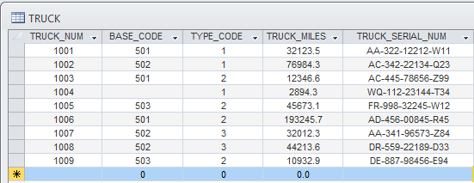

Table Name:- BASE

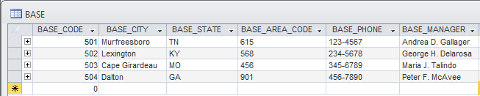

Table Name:- TYPE

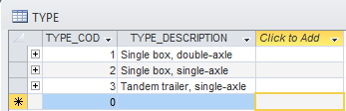

1. For each table, identify the primary key and the foreign key(s). If a table does not have a foreign key, write None.

***Answer:***

Truck table Primary Key: TRUCK_NUM

Base table Primary Key: BASE_CODE

Type table Primary Key: TYPE_CODE

1. Do the tables exhibit entity integrity? Answer yes or no and explain your answer.

***Answer:***

For each table the primary keys contain ***no*** null values, and ***yes*** uniqueness so also *yes* entity integrity.

1. Do the tables exhibit referential integrity? Answer yes or no explain your answer.

***Answer:***

Table 1 exhibits referential integrity. The Truck table has foreign keys, so in order to determine referential integrity by first checking values in table’s foreign key attributes against the set of values appearing in the primary keys of related tables. But since there was no separate values existing and only a single case of a null entry (BASE_CODE attribute for TRUCK_NUM 1004), since existence of null entries and matching entries does not violate the rules for referential integrity then the answer is it does exhibit it.

1. Identify TRUCK tables candidate key(s).

***Answer:***

Candidate Key = [TRUCK_NUM] This is Actually the Selected Primary Key

Candidate Key = [TRUCK_SERIAL_NUM] Another good option since uniquely assigned

Candidate Key = [TRUCK_MILES] A poor selection see below*

*Larger sets of data are likely to cause problems under with truck mileage being non-unique, which would then make this not be a candidate key. However in the current state of the tables only 9 actual Truck entries exist in it and it remains a candidate key.

1. For each table, identify a superkey and a secondary key.

***Answer:***

Superkey = [TRUCK_SERIAL_NUM, BASE_CODE, TYPE_CODE]

Secondary Key = [BASE_CODE, TYPE_CODE]

The superkey contains candidate key TRUCK_SERIAL_NUM

The secondary key attributes separate the data into different subsets from Base/Type,

e.g. Base 501-502 and Type 2.

1. Create the ERD for this database.
2. Create the relational diagram for this database.

**Problem 2**:- [16 Points]

The Jonesburgh County Basketball Conference (JCBC) is an amateur basketball association. Each city in the county has one team as its representative. Each team has a maximum of 12 players and a minimum of 9 players. Each team also has up to three coaches (offensive, defensive, and physical training coaches). During the season, each team plays two games (home and visitor) against each of the other teams. Given those conditions, do the following:-

1. Identify the connectivity of each relationship.

Team to Player is 1:1

Team to City is 1:M

Team to Coaches is 1:M

Team to Games is M:M

1. Identify the type of dependency that exists between CITY and TEAM.

Pg 108…

1. Identify the cardinality between teams and players and between teams and city.
2. Identify the dependency between coach and team and between team and player.
3. Draw the Chen and Crow’s Foot ERDs to represent the JCBC database.
4. Draw the UML class diagram to depict the JCBC database.

**Problem 3**:- [10 Points]

Create an ERD based on the Crow’s Foot notation, using the following requirements:-

1. An INVOICE is written by a SALESREP. Each sales representative can write many invoices, but each invoice is written by a single sales representative.
2. The INVOICE is written for a single CUSTOMER. However, each customer can have many invoices.
3. An INVOICE can include many detail lines (LINE), each of which describes one product bought by the customer.
4. The product information is stored in a PRODUCT entity.
5. The product’s vendor information is found in a VENDOR entity.

**Problem 4:- [11 Points]**

Using the Crow’s Foot notation, create an ERD that can be implemented for a medical clinic, using the following business rules:-

* A patient can make many appointments with one or more doctors in the clinic, and a doctor can accept appointments with many patients. However, each appointment is made with only one doctor and one patient.
* Emergency cases do not require an appointment. However, for appointment management purposes, an emergency is entered in the appointment book as “unscheduled.”
* If kept, an appointment yields a visit with the doctor specified in the appointment. The visit yields a diagnosis and, when appropriate, treatment.
* With each visit, the patient’s records are updated to provide a medical history.
* Each patient visit creates a bill. Each patient visit is billed by one doctor, and each doctor can bill many patients.
* Each bill must be paid. However, a bill may be paid in many installments, and a payment may cover more than one bill.
* A patient may pay the bill directly, or the bill may be the basis for a claim submitted to an insurance

company.

* If the bill is paid by an insurance company, the deductible is submitted to the patient for payment.